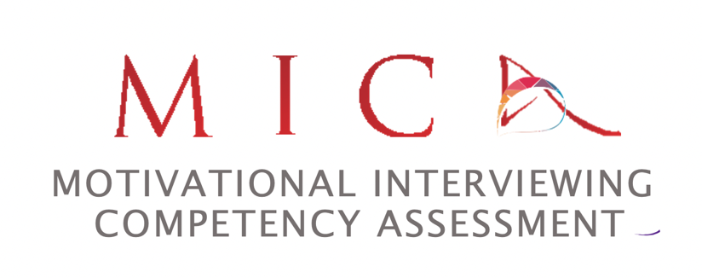

Motivational Interviewing Competency Assessment (MICA):
The Foundations

Ready to evaluate motivational conversations? Provide feedback to others for skill enhancement? Elevate your self-reflection for improved skill?

The MICA is a valid and reliable rating instrument for assessing motivational conversations. The MICA relies on the principles, strategies and approach as presented in Miller & Rollnick’s Motivational Interviewing: Helping People Change, Third Edition. The MICA allows users to evaluate a practitioner’s helping conversation, assess MI competence from a quality assurance perspective, and provide a quality improvement process to move from beginning use of MI to proficient demonstration. Ultimately, MICA’s goal is to provide professionals with easily digestible, structured and specific feedback regarding their effort to use MI with those they serve.

This 6-hour Foundations workshop will introduce participants to the MICA’s 2 strategies and 5 intentions, plus provide opportunities to rate motivational conversations using the MICA. From this foundation, you will be able to decide for yourself, your organization and/or your system of care whether to learn more about the MICA and implement into evaluation and skill development processes.

When: Tuesday, March 21 and Thursday, March 23, 2023: 11:30a to 2:30p ET each day
Where: Via Zoom, link to be sent a week before the course meets
Cost: 200.00 USD
To Register: please contact Ali Hall at mi.consult.ahall@gmail.com

Your Facilitator:

Ali Hall
Member of the Motivational Interviewing Network of Trainers (MINT)
MINT Certified Trainer
MICA co-developer
www.alihalltraining.com

