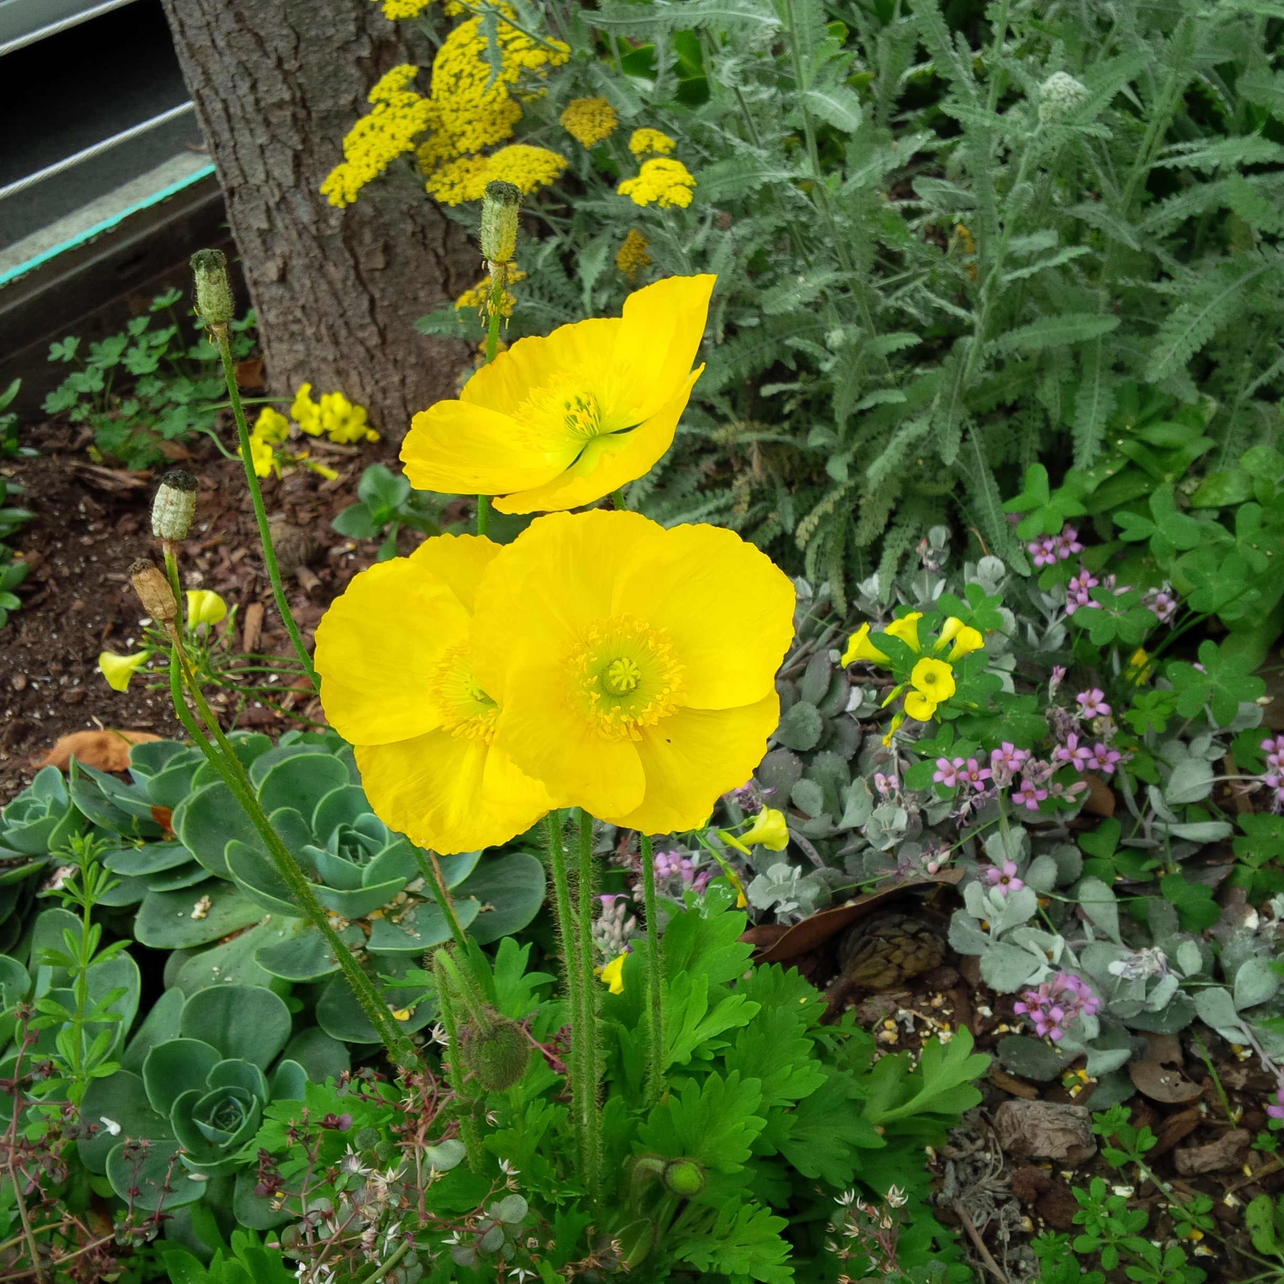

**Motivational Interviewing Competency Assessment (MICA) Coding Circle**

**January 17, 2020**

**2:00-3:00pm Eastern Standard Time**

Please join for a free one-hour MICA coding circle!

Register your interest by 1/1/20 using this link: <https://www.signupgenius.com/go/70a0b4aada828a6f58-mica1>

If you are registering with others and will be using the same computer or phone line, you can just register as a group.

We will make an audio recording available around January 1, 2020 and send out a Zoom invitation and Survey Monkey link for those registered.

We ask that you code the work sample by January 10, using the MICA v3.0, and enter your codes using a Survey Monkey link that will be provided.

We expect to host these free coding circles quarterly. We will announce the next session(s) by 1/17/20.

Facilitators: Ali Hall JD and Susan Butterworth, PhD

Members of the Motivational Interviewing Network of Trainers and MICA Co-Developers