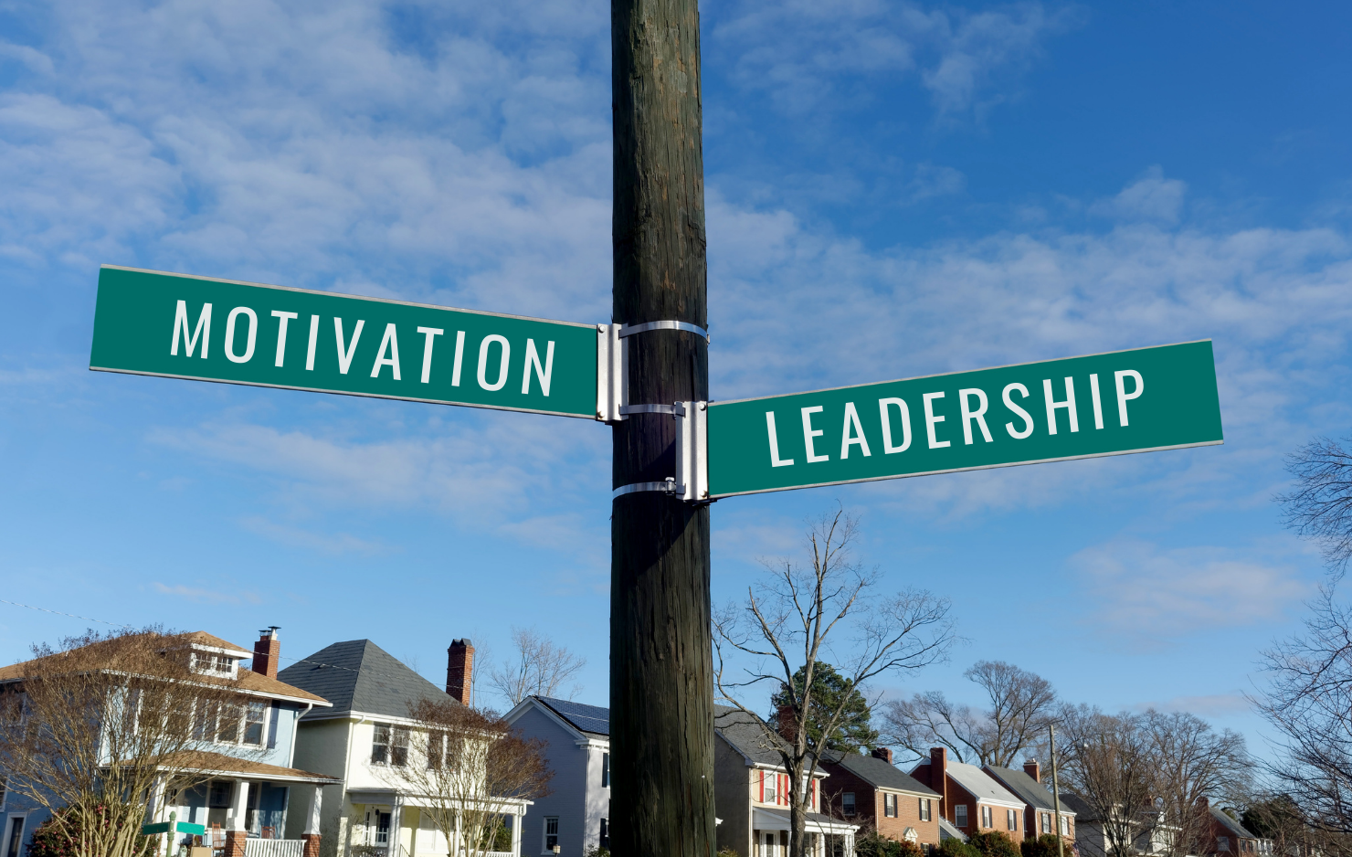
For people leading from any chair

At the Vital Intersection of Leadership &

Motivational Conversation
What: Connect to your own heart of transformational leadership; explore challenges, goals & aspirations as leaders in any aspect – from any chair—exercise new tools and strategies; network, learn and use 4 key motivational processes: engaging, focusing, evoking and planning; facilitate transformation for people in your personal and professional life, and help your organizations flourish
Where: Together in our Zoom café, with Google Docs and Slides
When: February 4, 11, 18, 25, 2021 from 5-6:30 pm EST
Cost: $100 for the series, paid via Venmo: https://venmo.com/Amy-Shanahan-13
Prerequisites: An eager open heart and mind and the desire to transform as a leader to focus your intentions, fire up your motivations, and increase your own personal and professional effectiveness.
Who: Ali Hall & Amy Shanahan will be your guides for this 4-session collaboration. Ali Hall (she, her, hers) & Amy Shanahan (she, her, hers) are consultants/coaches who have led from a variety of chairs in their personal and professional lives. They are members of the Motivational Interviewing Network of Trainers and are committed to creating communities of practice. Ali consults regularly with corporate & non-profit organizations for best-practices implementation and has facilitated more than 2500 Motivational Interviewing (MI) workshops for helping professionals. Ali completed her graduate studies in law and organizational behavior/design at the Cornell University School of Industrial and Labor Relations and School of Law; Amy has co-led as a parent, led teams in non-profit behavioral health clinics, & has facilitated creative problem solving & training sessions for over 25 years. Amy has a Master of Science degree from the International Center for Creative Studies & Change Leadership from Buffalo State College.
Ali & Amy look forward to sharing tools and strategies from their experience in a collaborative learning exchange over the 4 sessions:
- Session 1: Engage, lead and partner for change. Register here: Session 1
- Session 2: Focus, share the agenda and collaborate for change. Register here: Session 2
- Session 3: Evoke our own and other’s motivation, the fuel for change. Register here: Session 3
- Session 4: Plan, strengthen and solidify commitments for transformation. Register here: Session 4

