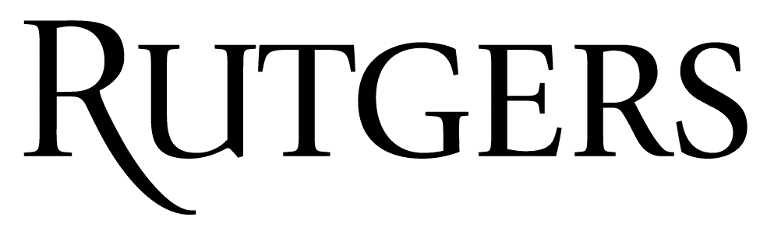 | Disclosure Declaration Form

As an accredited continuing education provider, Rutgers Biomedical and Health Sciences and Rutgers UBHC is required to collect disclosure information from all individuals in a position to control the content of an educational activity, and then identify and mitigate all relevant financial relationships prior to individuals assuming their roles in the activity. Based on this disclosure information, Rutgers is required to disqualify any individuals from planning and implementation if an unresolvable financial relationship exists. This process is required by the Standards for Integrity and Independence set forth by the Accreditation Council for Continuing Medical Education (ACCME) and adopted by Joint Accreditation for Interprofessional Continuing Education™, Rutgers’ accrediting entity.

Individuals are required to disclose all financial relationships with ineligible companies (entities whose primary business is producing, marketing, re-selling, or distributing healthcare products used by or on patients) within the prior 24 months. There is no minimum financial threshold; all financial relationships with ineligible companies, regardless of the amount, must be disclosed. Individuals must disclose all financial relationships regardless of the potential relevance of each relationship to the education. Financial relationships of spouse/partner should not be disclosed.

All disclosure declarations must be communicated to the learner by means of a notation in the program or syllabus. Individuals who do not provide the requested disclosure information will be disqualified from participating in the development and delivery of a CE activity.

ICMI 2022 Session Title:
Presenter Name:
Please answer all the questions and sign on the last page.

- Do you have any financial relationships with ineligible companies (entities whose primary business is producing, marketing, re-selling, or distributing healthcare products used by or on patients) in any amount within the past 24 months?
Examples of ineligible companies include:
- Pharmaceutical companies or distributors  - Bio-medical startups that have begun a governmental regulatory approval process  - Diagnostic labs that sell proprietary products  - Growers, distributors, manufacturers or sellers of medical foods and dietary supplements  - Pharmacy benefit managers | - Device manufacturers or distributors  - Compounding pharmacies that manufacture proprietary compounds  - Manufacturers of health-related wearable products  - Advertising, marketing, or communication firms whose clients are ineligible companies  - Reagent manufacturers or sellers
☐ Yes, in the past 24 months, I have had at least one financial relationship with an ineligible company.
☐ No, in the past 24 months, I have not had any financial relationships with any ineligible companies.

- If Yes, please list in the table on the following page the ineligible companies with the nature of the financial relationship. Please attach a separate page if necessary.
- Examples of financial relationships include, but are not limited to, researcher, consultant, advisor, speaker, independent contractor (including contracted research), royalties or patent beneficiary, employee, executive role, and owner interest.
- Individual stocks and stock options should be disclosed; diversified mutual funds do not need to be disclosed.
- Research funding from ineligible companies should be disclosed by the principal or named investigator even if that individual’s institution receives the research grant and manages the funds.

NAME OF INELIGIBLE COMPANY | NATURE OF FINANCIAL RELATIONSHIP | HAS THE RELATIONSHIP ENDED?  If the financial relationship existed during the last 24 months, but has now ended, please check the box in this column.
 |  | ☐
 |  | ☐
 |  | ☐
 |  | ☐
 |  | ☐
 |  | ☐
 |  | ☐
 |  | ☐
 |  | ☐
 |  | ☐
 |  | ☐
 |  | ☐
 |  | ☐
 |  | ☐
 |  | ☐
 |  | ☐
 |  | ☐
 |  | ☐
 |  | ☐
 |  | ☐

I attest that the information I have provided is correct and complete as of the date of submission of this form and I accept responsibility for the accuracy of the information in response to the aforementioned questions.

______________________________________________________________________________________________
Signature Date

