Motivational Interviewing
Training Series

Denise Ernst, Ph.D.
Stéphanie Wahab, Ph.D., M.S.W.
Two-Day Introduction to Motivational Interviewing (MI)
May 3-4th, 2018 - $450
This 2-day intensive workshop (part of an MI training series—ask for flyer) will:
- Describe the “spirit,” key principles and four processes of Motivational Interviewing (MI)
- Critically engage MI demonstrations via videos and live examples
- Demonstrate and practice the spirit and primary skills associated with MI, with specific attention to evoking change talk
- Become familiar with and practice the range of skills used in MI to engage with clients, focus the scope of the work, evoke change talk, dancing with discord and negotiate a change plan
Target Audience
These trainings are appropriate for helping professionals and paraprofessionals in the role of supporting individuals to make and sustain behavior changes: social workers, physicians, nurses, health educators, care managers, dieticians, counselors, psychologists, life and health coaches, clergy, probation/corrections officers, personal trainers, school counselors, and educators.

Included in the Workshop
- 14 hours of high-level training from national and international MINT trainers
- Light breakfast/Coffee Breaks/Light Snacks
- University venue with local food carts and hotels within walking distance
- 13 Social Work CEUs (6.25 and 6.75 Hours)

Daily Schedule
8:30am-4:30pm; Lunch: 12:00-1:15pm
Training Location - Portland State University
Smith Memorial Student Union, Cascade Room 238
1825 SW Broadway, Second Floor
- Located in the heart of downtown Portland in the middle of campus. (See map on next page.)
- Easily accessible via public transportation, with a host of nearby accommodations and restaurants.
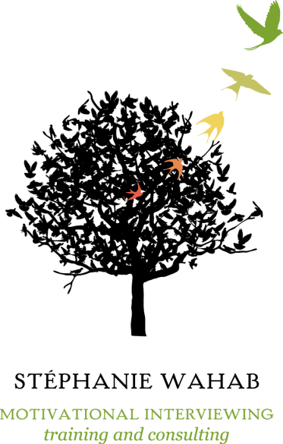
Held in beautiful Portland, Oregon at Portland State University

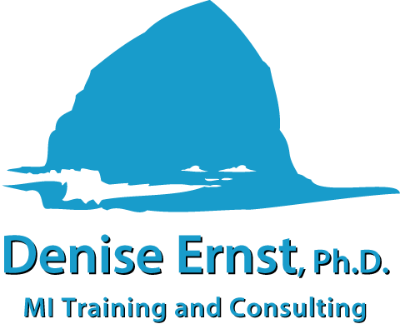
Limited to 30 participants—register TODAY!
DeniseErnst.com
WahabTraining.com
More about the MI Training Series
with Dr. Ernst and Dr. Wahab
MI Training Location

Portland State University
Smith Memorial Student Union, Cascade Room 238
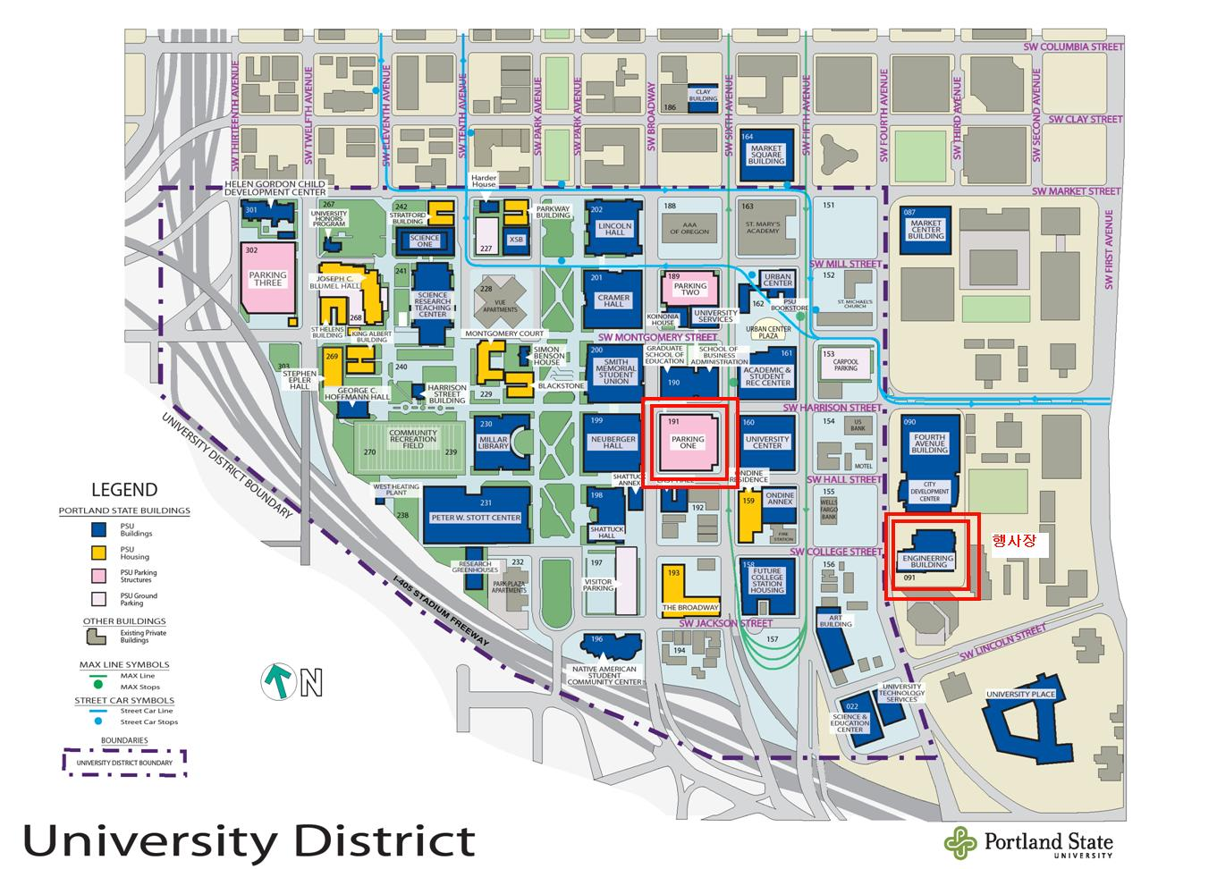
1825 SW Broadway, Portland
